**What is Hatha Yoga?**

“Ha” - Sun  
“Tha” - Moon

It is the practice of balancing the sun and moon energies in the body. Yoga exercises are challenging; Hatha yoga asanas help us achieve a balance between the left and right channels, also known as nadis, to reach a higher consciousness of life.

**Hatha Yoga Poses for Beginners**

**Tadasana (Mountain Pose)**

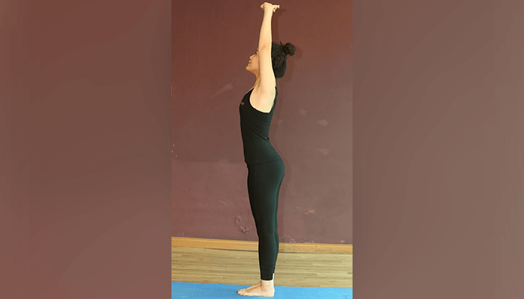

The mountain pose is a staple of Hatha yoga for beginners and it is the base for all the standing [**yoga asanas**](https://fitpass.co.in/blog/6-early-morning-yoga-poses). It switches on all muscle groups and is great for body posture. Perform tadasana on an empty stomach and practice control to avoid injuries.

**How to do Tadasana**

1. Stand straight with your feet together and your toes touching each other. Your heels can be slightly apart
2. Place your hands firmly alongside your body and ensure that your thighs are firm
3. Lift your kneecaps but do not harden your lower stomach
4. The arches of your inner ankles should be straight as you lift them
5. Gently turn your upper thighs inward and stretch the tailbone toward the floor. Lift your pubis toward the navel
6. Look straight ahead and fix your gaze at a single point for balance
7. Breathe in as you stretch your arms upwards; let your body stretch from head to toes
8. Hold for up to 60 seconds. Exhale as you release

**Vrikshasana (Tree Pose)**

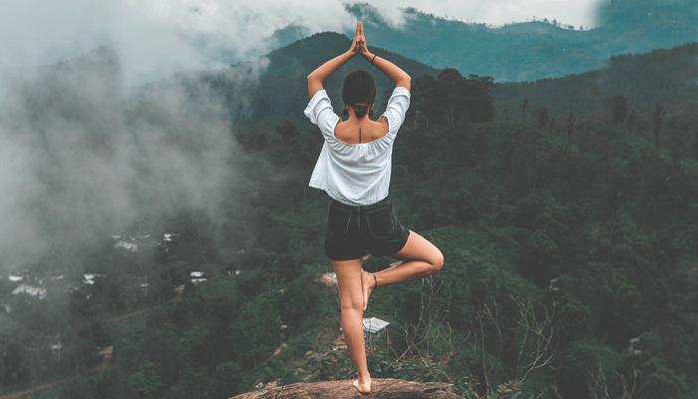

The tree pose stretches the legs, arms, and the back in addition to promoting equilibrium in your mind. Vrikshasana is one of the [**Hatha yoga**](https://fitpass.co.in/hatha-yoga-classes-in-janakpuri) poses for beginners that relieves sciatica, makes legs strong, opens up the hips, and improves balance. It is known to improve concentration as well.

**How to do the Vrikshasana**

1. Stand straight with your arms on your sides
2. Place your right foot on the inside of your left thigh. Place the sole flat and firmly on the root of the thigh. Ensure that the left leg is straight
3. Find your balance, breathe, and slowly raise your arms over your head from the sides. Join your palms in Namaste mudra
4. Look straight ahead in front of you at a single point to maintain balance
5. With your body tightly stretched and the spine straight, take long deep breaths. Relax with each breath
6. Gently bring your hands down and release the leg
7. Repeat the pose with the other leg after a few seconds of rest

**Uttanasana (Standing Forward Bend)**

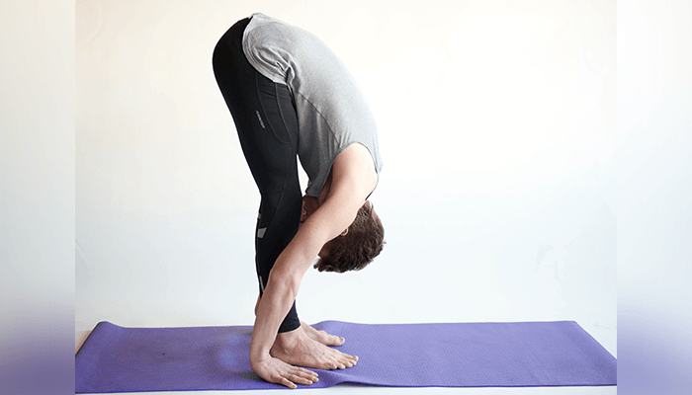

The standing forward bend or the Uttanasana benefits body and mind. Although it is uncomplicated it is anything but easy as it requires flexible hamstrings, calves, hips, and above all, patience. This simple pose is a reflection of the ebbs and flows in your body and life.

**How to do Uttanasana**

1. Stand straight and place your hands on your hips. Exhale and bend forward hinging from your hips
2. Stretch as much as you can from your hips to your head
3. Touch the fingertips on the ground or a block. Release the back  of your head and neck
4. Feel your torso lengthen as you inhale and feel your chest reach toward your toes as you exhale
5. Hold the pose for up to 60 seconds
6. To release the pose, let your hands go back up to your hips and slowly raise your torso

**Adho Mukha Svanasana (Downward-facing Dog Pose)**



One of the most common  [**yoga poses**](https://fitpass.co.in/blog/10-yoga-poses-digestion), Adho Mukha Svanasana promotes blood flow to the brain. Performing the downward-facing dog pose energizes, strengthens, and lengthens the muscles. It tones the core and the waist, lengthens the hamstrings & calves, and strengthens the back.

**How to do Adho Mukha Svanasana**

1. Get on all fours so that your body resembles a table. Ensure that your hands are in line with your shoulders and the feet are in line with your hips
2. Exhale and lift your hips. Simultaneously, straighten your elbows and knees. Your body should make an ‘inverted V’ position and toes should point outward
3. Lengthen your neck by pressing your hands into the ground. Let your ears touch your inner arms
4. Hold for a few seconds
5. Bend your knees to release the hold

**Setu Bandhasana (Bridge Pose)**



The Bridge Pose is a part of Hatha Yoga that improves core and lower body strength in addition to lengthening the spine. Performing the Setu Bandhasana improves energy levels in the body and stimulates the nervous system and the endocrine system.

**How to do Setu Bandhasana**

1. Lie on a yoga mat on your back and bend both your knees. Place your feet at hip-width, flat on the floor
2. Keep your arms alongside your body with the palms facing down. Your fingertips should lightly touch your heels
3. Inhale and lift your hips by pressing the feet into the floor; roll the spine off the floor. Maintain the hip-width between your knees
4. Lift your chest by pressing down into the arms and shoulders
5. Lift your hips as high as possible with the help of your legs and buttocks
6. Hold for up to 4-8 breaths
7. Exhale and let the spine roll back to the floor slowly to release

**Halasana (Plough Pose)**

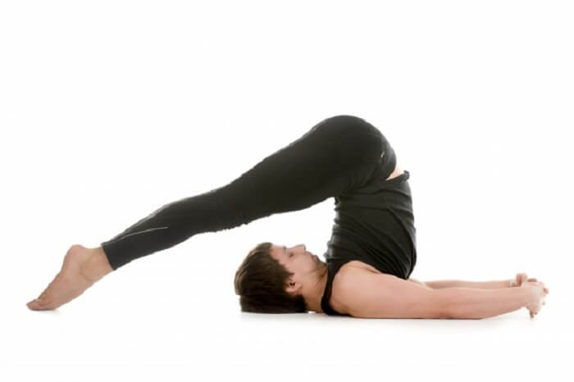

Among the Hatha Yoga poses, the Halasana is one that is associated with finding the treasures inside, which is synonymous with the plough. The Plough Pose benefits include reduced stress and fatigue in addition to a calm brain, flexible shoulders & spine, and relief in the symptoms of menopause. The pose is therapeutic for insomnia, sinusitis, infertility, backache, and headache.

**How to do Halasana**

1. Lie down flat on a mat on your back and place your arms beside your body. Your palms should face downward
2. Inhale and use your abdominal muscles to lift your feet off the ground. At this point, your feet should be at a square angle to your torso
3. Push your hands down into the floor to lift your hips off the floor. Your feet should be directly over your head and then beyond it; your back must be perpendicular to the ground
4. Hold the position for a few seconds and focus on your breathing meanwhile
5. Exhale and let your feet come to the original position slowly; avoiding any jerky movements

**Sirsasana (Head Stand)**

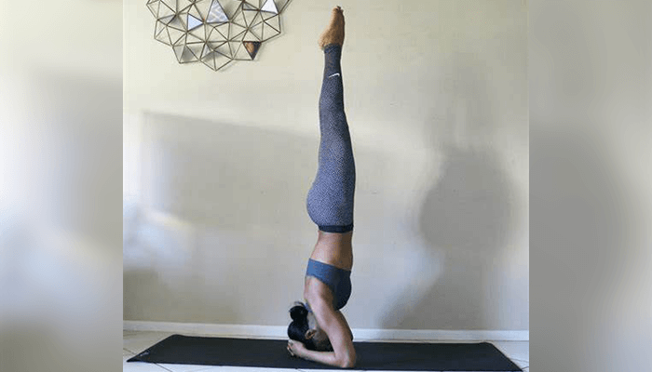

The health benefits of Headstand are amazing. This Hatha Yoga pose increases blood flow to the head, neck, and face. Sirsasana relaxes the flow of blood to the lower extremities, which reduces swelling and nervous congestion. The Headstand benefits the heart by relaxing it and releases the kidneys and the adrenal glands.

**How to do Sirsasana**

1. Get on all fours just like in the downward-facing dog pose
2. Place your forearms on the floor with your elbows directly under the shoulders
3. Clasp your hands together by interlacing your fingers and make a cup with your palms
4. Next, place the top of your head on the floor with your palms cupping the back of your head
5. Stretch out your legs as you would in the downward-facing dog pose
6. Slowly walk your feet toward your head as far as possible
7. Give your legs a push and lift them off the floor. Don’t try to go directly into the full extension. Let your legs hang with thighs bent hinging from the hips and your back straight
8. Next, straighten your thighs in line with your backbone and let your shins hang toward the back
9. Hold this position and take a few deep breaths
10. Exhale and slowly unbend your knees to fully extend your lower body
11. Keep your core engaged and hold the pose for at least 10 seconds

(Never kick up into the headstand. You can also go for the alternative way – start by extending one leg and then the other)

**Salabhasana (Locust Pose)**



The Salabhasana mirrors a locust at rest but it is much more difficult than resting. The Locust Pose improves blood circulation and stimulates the internal organs. Performing this Hatha Yoga pose for beginners regulates the acid-base balance as well as strengthens the thighs, shoulders, legs, hips, and calf muscles. The Salabhasana is included in the routine of [**yoga for weight loss**](https://fitpass.co.in/weight-loss-classes-near-me) since it regulates metabolism and reduces stress and tension.

**How to do Salabhasana**

1. Lie down on a yoga mat on your abdomen and place your hands by your side
2. Inhale and lift your legs and upper torso
3. Without bending your knees, lift your legs higher upward using your inner thighs. Let your weight rest on your abdomen and lower ribs. Use your hands for support
4. Hold the pose for up to 1 minute and then release slowly

**Sarvangasana (Shoulder Stand)**

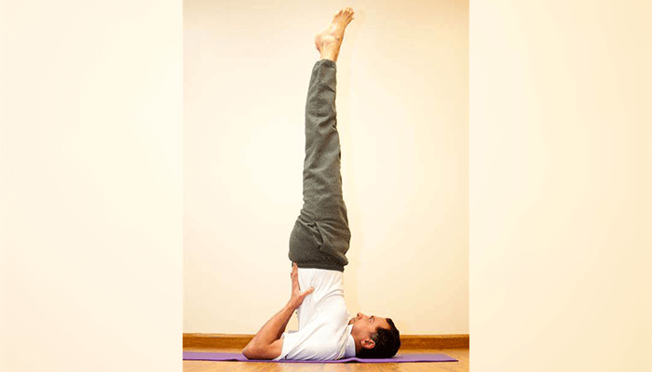

The shoulder stand or the Sarvangasana is a Hatha Yoga asana that influences the functionality of all the parts of the body. Also known as the “queen of the asanas”, the Shoulder Stand benefits mental and physical health. The whole body is balanced on the shoulders in the Sarvangasana.

**How to do Sarvangasana**

1. Lie on your back and place your hands on your sides
2. Support your back with your hands and lift your legs, buttocks, and the back with one movement (in that order)
3. Move your hands lower down your upper back and your elbows closer toward each other. Straighten the legs and spine by pushing down on your elbows. Make sure that all of your weight is on your shoulders and upper arms and not on your neck or head
4. Do not let your legs wobble. Stretch your heels up higher and bring your toes directly above your nose. Do not press the neck into the floor; release the pose if you feel any pressure on it
5. Take deep breaths and hold the pose for 30-60 seconds
6. Lower the knees to the forehead to release. Bring your hands to the floor and then the spine down on the floor very slowly
7. Relax for at least 1 minute

**Dhanurasana (Bow Pose)**



The Bow Pose is based on the fact that the spinal cord is the most important part of the body. The Bow Pose benefits the abdominal muscles as well as the back. It is known to stimulate the reproductive organs in addition to opening up the neck, chest, and shoulders. It makes the back flexible and reduces stress and menstrual discomfort.

**How to Dhanurasana**

1. Lie on your stomach on the mat with your feet at hip-width. Keep your arms beside your body
2. Gently fold your knees and hold your ankles
3. Inhale and lift your chest and legs off the ground and pull your legs back
4. Keep your gaze straight ahead and don’t let your face stress
5. Concentrate on your breathing while you hold the pose; let your body be as taut as a bow
6. Take long and deep breaths
7. Release the pose after 15-20 seconds